Control Voltage and its effects on Raman channels

-Herman Li

-11/5/22

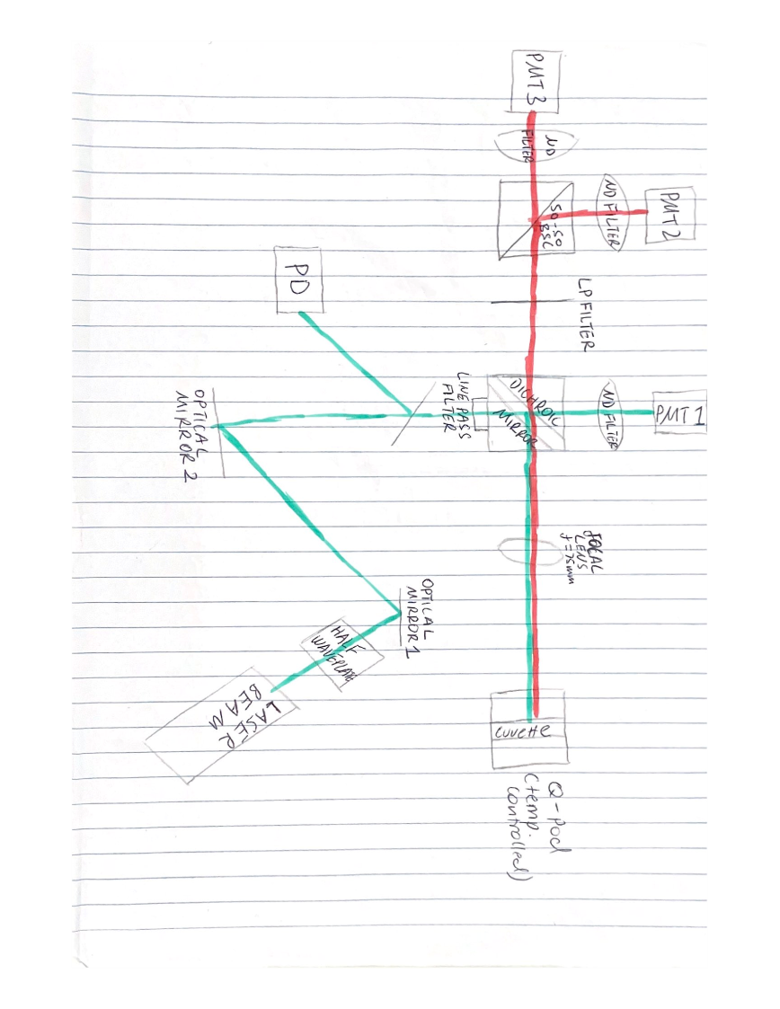Using the exact set up from “Observing attenuation effects on correlation and noise significance various channels” report, we are focusing on the 2 Raman channels and observing how altering the control voltage would affect their signal.

A schematic diagram of the setup is shown below:

Instead of taking individual datasheets in the form of a csv file and analysing afterwards, the measure function of the Tektronix oscilloscope was applied and the values were simply recorded into excel.

The aim was to determine how the following variables responded to changing control voltage:

* Background
* Noise (peak to peak)
* Pulse Peak

To collect data on the pulse peak, the wave inspector is zoomed in on the pulse, the peak value is assumed to be the maximum value detected by the measure function on the oscilloscope.

To collect data on the background and noise (peak to peak), the wave inspector on the oscilloscope was used to focus on a region far before the pulse of the laser. Here, the mean background, mean noise and their corresponding standard deviations are recorded using the measure function.

For now, we are not interested in what happens after the pulse.

These measurements are firstly recorded with no attenuation where the excitation pulse is at 175mV (with trigger at 102mV) and then repeated with attenuation such that the excitation pulse is at 1/3 of its power, or 60mV (with trigger at 45.6mV).

**Observation and Discussion:**

Varying control voltage without attenuation, the following are the outputs of the Raman channels.

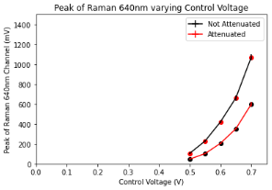This is the response from Raman 640nm Channel:

The signal increases exponentially with increasing control voltage ranging from about 40mV to 1000mV and 20mV to 600mV for the non-attenuated and attenuated response respectively. The plot on the right is of the same plot but using a log scale, the log of an exponent should return a linear function and our functions are roughly linear.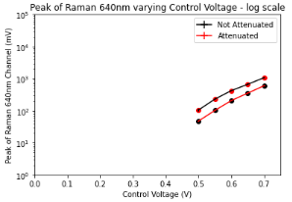

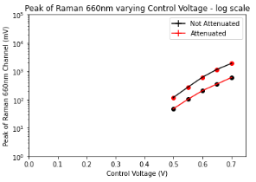This is the response from Raman 660nm Channel:

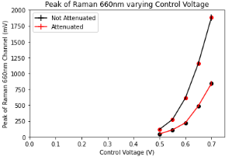Again, the signal increases exponentially with increasing control voltage as expected. The signals range from about 40mV to 1.9V and 20mV to 800mV for the non-attenuated and attenuated response respectively. Again, the plot on the right is the same plot in log scale and is expected to return a linear plot, while it seems like the attenuated response is quite linear, the non – attenuated response could be beginning to roll over?

Determining the overall shape could be improved if a larger range of control voltage was applied in experiment. However, as the voltage had already approached 1.9V for Raman 660nm channel, it was perhaps wise to stop and for the sake of unity, all other channel measurements stopped at a control voltage of 0.7V.

Note that there is a very small uncertainty of control voltage as it seemed to fluctuate about 0.001V. The uncertainty for the peak values are incorporated into the plots shown above (using the error bar plot in python), since the uncertainty (calculated by standard deviation) is so small, it hardly noticeable on the graphs.

Moving onto the background and noise analysis,

This is the response from the Raman 640nm:

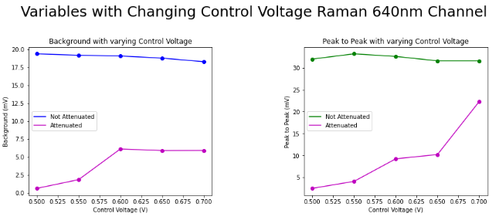The plot on the left shows how the background of non-attenuated and attenuated response varies with increasing control voltage. As labelled, the blue represents the non-attenuated response and is roughly a straight line, it is possible to be quite certain of this as everything falls inside the standard deviation. When attenuated, the background seems to increase and plateaus at 0.6V (control voltage).

The plot on the right shows how the noise level of non-attenuated and attenuated response varies with increasing control voltage. A similar situation is occurring where without attenuation, there seems to be no change with control voltage – again, even though the slope is a little jagged, all points fall under the standard deviation, so there is no sign of increasing or decreasing with increasing control voltage. However, when attenuated, it is clear to see that the noise increases quite rapidly with increasing control voltage.

This is the response from the Raman 660nm:

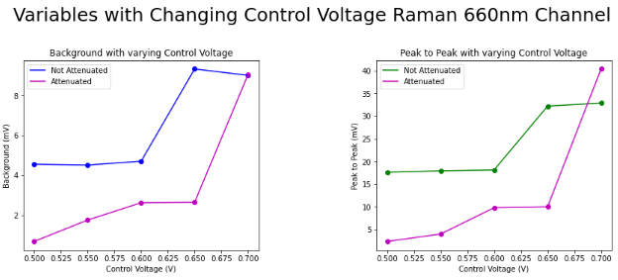The plot on the left is how the background for both non-attenuated and attenuated response varies with increasing control voltage. The non-attenuated response seems flat and unchanging until the control voltage reaches 0.65V, it shoots up by roughly 5 mV (to 9mv) and given the uncertainties seem to flatten there, it would be easier to determine this if the range of control voltage could be increased. For the attenuated case, as control voltage increases, it seems to climb steadily, when the control voltage reaches 0.7V, it also shoots up to about 9 mV, what happens after that is undetermined. It is expected that the non-attenuated signals should stay above the attenuated signals, this is not strictly true for what is being shown here.

The plot on the right shows how the noise for both non-attenuated and attenuated response varies with increasing control voltage. Both cases here show a really similar response to the background signal. In the non-attenuated case, it is possible to assume that the control voltage has no effect on the signal using the same uncertainty argument, once the control voltage reaches 0.6V, it increases by about 15-20mV and possibly flattens there. For the attenuated case, as control voltage is increased, it slowly increases until the control voltage is at 0.7V, it increases by about 30mV and what happens after is undetermined. At the same control voltage, this increase has allowed the attenuated signal to be stronger than the non-attenuated signal, which is quite unexpected.